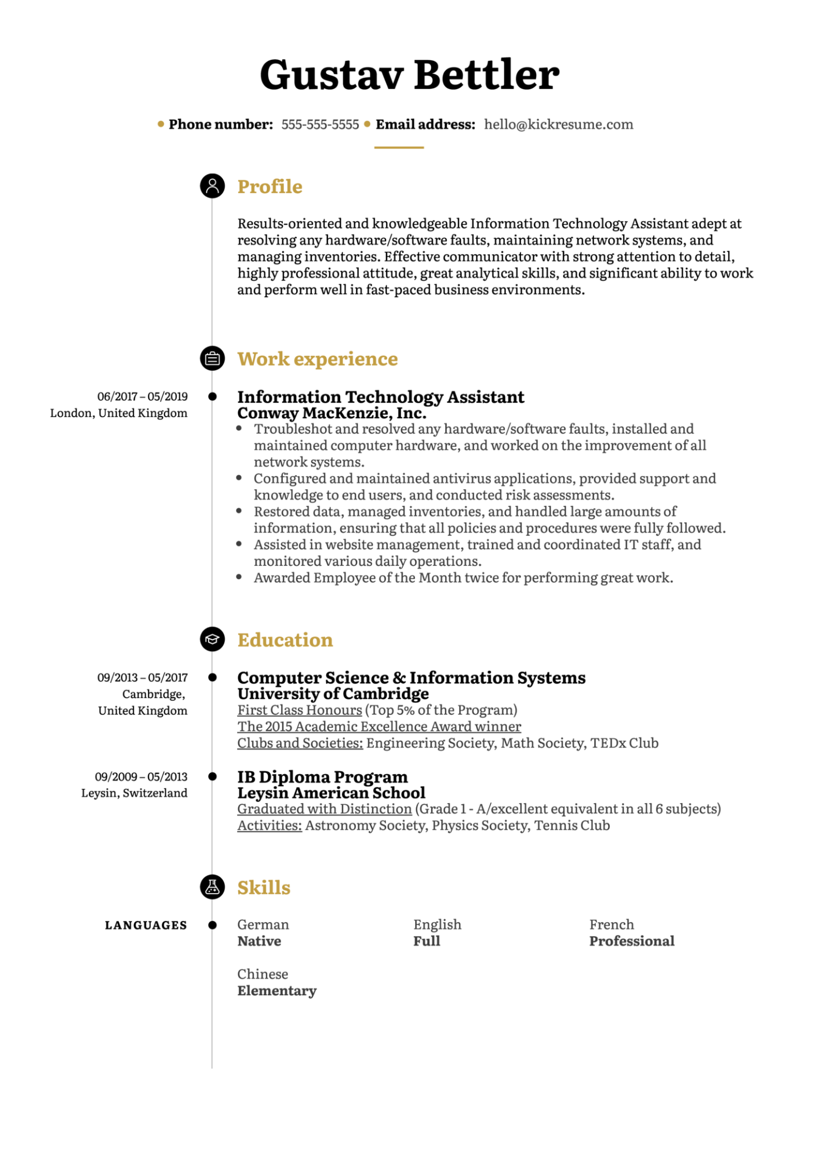
Gustav Bettler
⚫ Phone number: 555-555-5555 Email address: hello@kickresume.com
Profile
Results-oriented and knowledgeable Information Technology Assistant adept at resolving any hardware/software faults, maintaining network systems, and managing inventories. Effective communicator with strong attention to detail, highly professional attitude, great analytical skills, and significant ability to work and perform well in fast-paced business environments.
06/2017-05/2019
London, United Kingdom
Work experience
Information Technology Assistant
Conway MacKenzie, Inc.
Troubleshot and resolved any hardware/software faults, installed and maintained computer hardware, and worked on the improvement of all network systems.
• Configured and maintained antivirus applications, provided support and knowledge to end users, and conducted risk assessments.
• Restored data, managed inventories, and handled large amounts of information, ensuring that all policies and procedures were fully followed. • Assisted in website management, trained and coordinated IT staff, and monitored various daily operations.
• Awarded Employee of the Month twice for performing great work.
09/2013-05/2017
Cambridge, United Kingdom
09/2009-05/2013 Leysin, Switzerland
Education
Computer Science & Information Systems
University of Cambridge
First Class Honours (Top 5% of the Program)
The 2015 Academic Excellence Award winner
Clubs and Societies: Engineering Society, Math Society, TEDx Club
IB Diploma Program
Leysin American School
Graduated with Distinction (Grade 1 - A/excellent equivalent in all 6 subjects) Activities: Astronomy Society, Physics Society, Tennis Club
LANGUAGES
Skills
German
Native
English Full
French Professional
Chinese Elementary

